Training and User Manual

Document history

|  |  |  |  |  |
| --- | --- | --- | --- | --- |
| Version | Date | Author | Changes | Valid from |
| 1.0 | 29-Sep-2016 | Hardik Kansara |  |  |

Table of Contents

1 Installation 3

1.1 Step 1 : Run the installer 3

1.2 Step 2 : Follow the instructions of the installer until the end 3

1.3 Step 3 : Navigate to where the application was installed. For example: C:\Program Files (x86)\Weltec Project\Database Evaluator Client 5

1.4 Step 4 : Run the application as an administrator 5

2 Running the Application 6

2.1 Step 1 : Start DBEvaluation on Client Database System. (Run the application under administrator account who has full access on SQL Server instance.) 6

2.2 Step 2 : Initial loading screen. 6

2.3 Step 3 : Main Screen and SQL Server instance selection. 7

2.4 Step 4 : User Database selection (Optional) 8

2.5 Step 5 : Start gathering parameters values. 9

2.6 Step 6 : Saving of dump file. 9

# Installation

## Step 1 : Run the installer



## Step 2 : Follow the instructions of the installer until the end

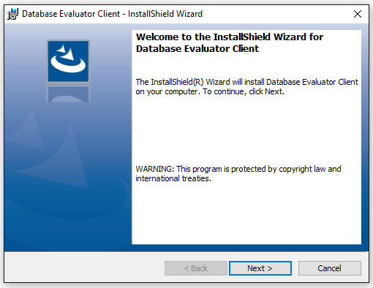

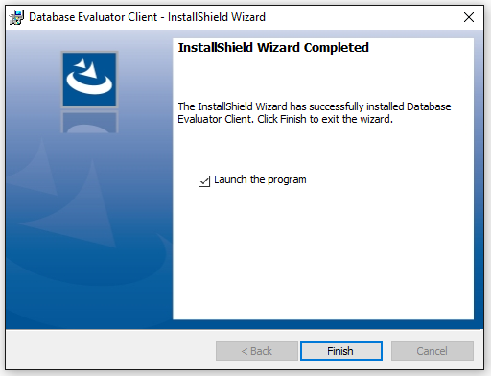

## Step 3 : Navigate to where the application was installed. For example: C:\Program Files (x86)\Weltec Project\Database Evaluator Client

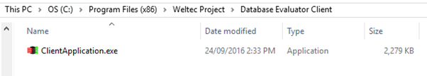

## Step 4 : Run the application as an administrator

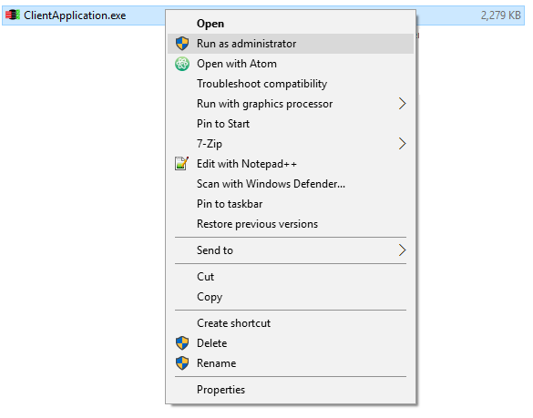

# Running the Application

## Step 1 : Start DBEvaluation on Client Database System. (Run the application under administrator account who has full access on SQL Server instance.)

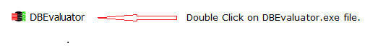

Initial screen it will appear immediately after this action.

## Step 2 : Initial loading screen.

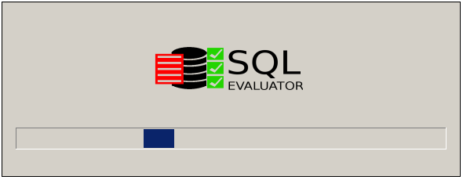

It will collect all the SQL Server instances details on the same domain network.

## Step 3 : Main Screen and SQL Server instance selection.

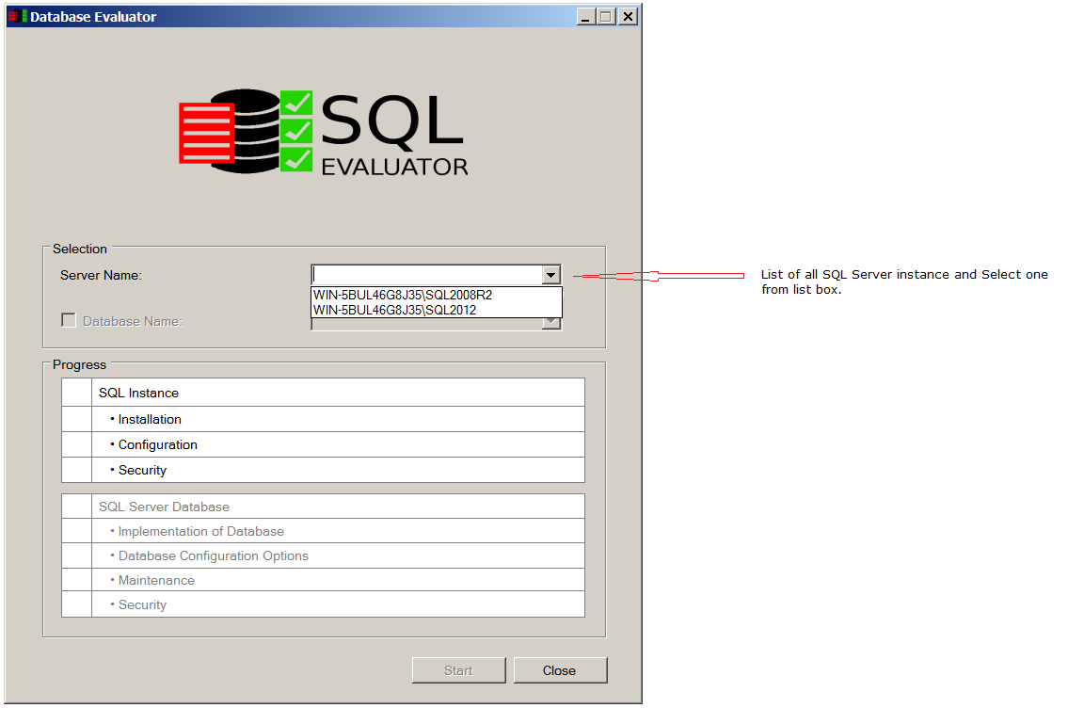

You can also enter the SQL Server instance name and press enter to connect.

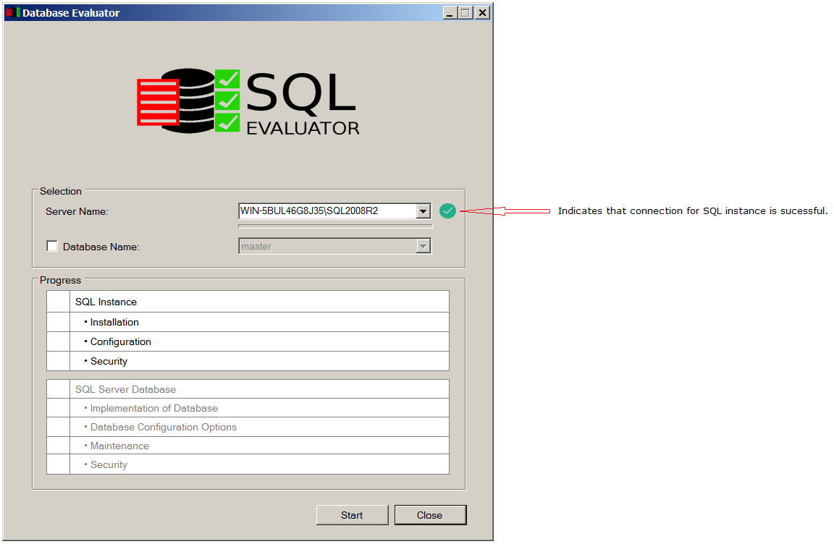

## Step 4 : User Database selection (Optional)

User can either evaluate SQL instance only or user can select at least one user Database to check.

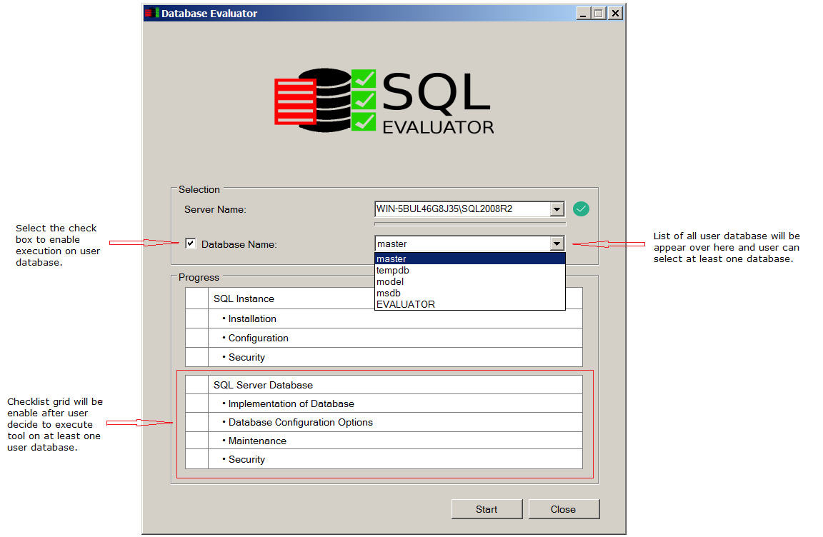

## Step 5 : Start gathering parameters values.

Click on Start button to start executing and collect the parameter values.

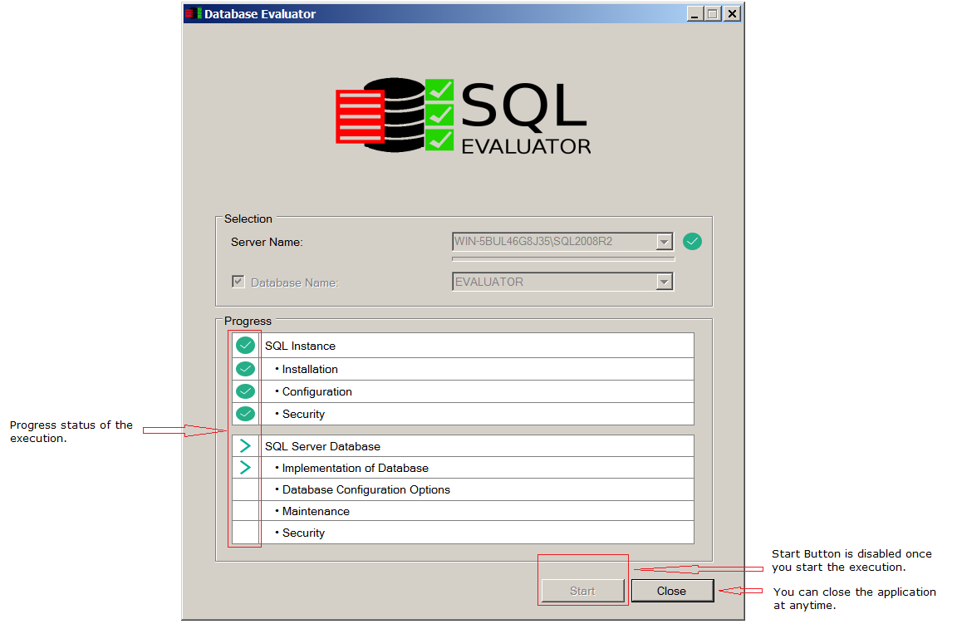

## Step 6 : Saving of dump file.

Application will ask you to save the dump file at the end of the execution. This dump file is encrypted and contains all the parameter values of the client database system.

